D.A.S.M ATHUKORALA

IT21169076

GROUP 2.1

SNP

**Exercise 01**

**1.**

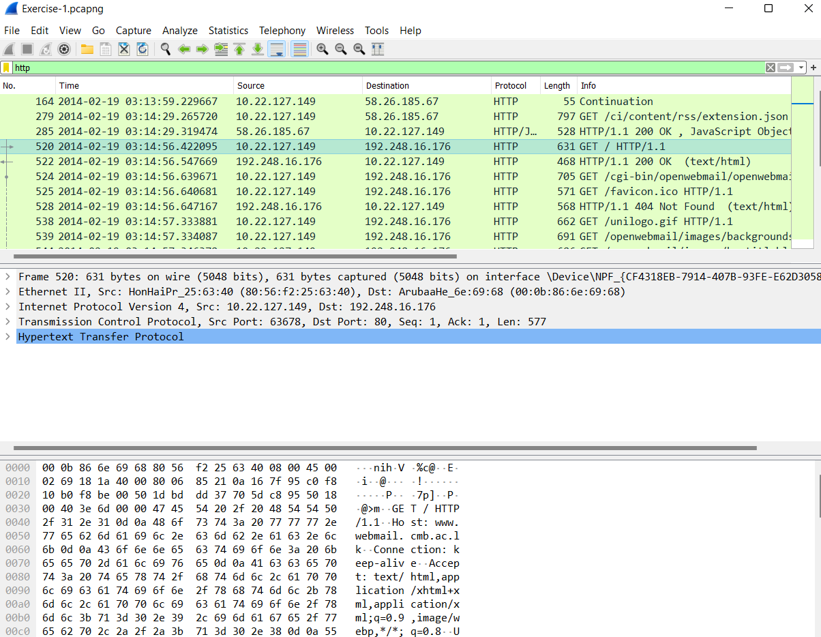

2.

192.168.3.129

3.

192.168.3.128

4.

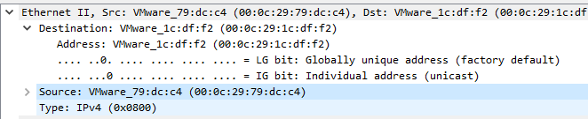

MAC Address- 00:0c:29:79:dc:c4

5.

2018-07-08 20:56:55.848235

6.

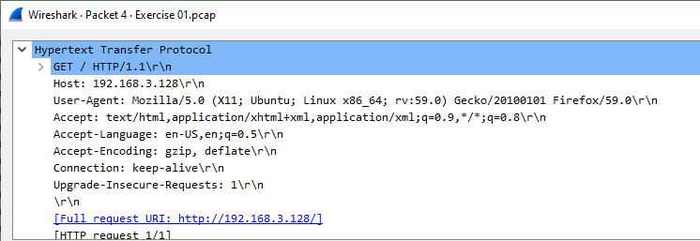

Mozilla/5.0 Browser

**Exercise 02:**

1. 98.114.205.102

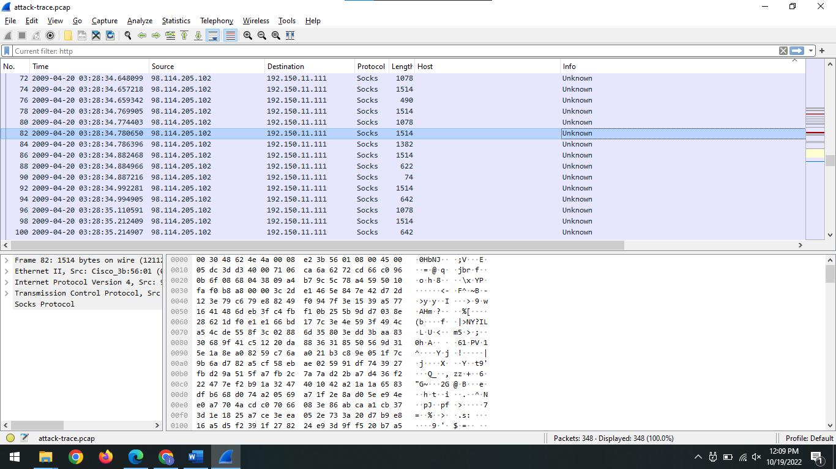

2.

a. Capture duration-

b. Start time –

2009-04-20 05:28:28

c. End time -   
2009-04-20 05:28:44

d. Number of packets - 348

e. Average packet size – 527

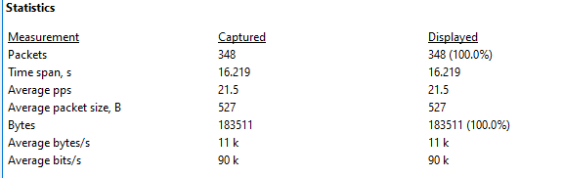

3.

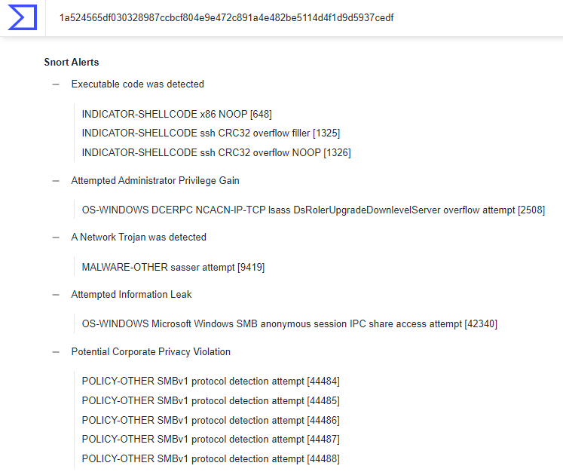

**Exercise 4**

1.

1. www.webmail.cmb.ac.lk\r\n

3.

